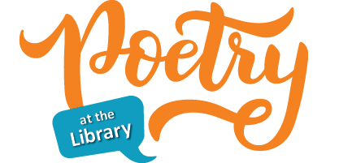

National Library Week and Easter aren’t the only special occasions in April; it is also National Poetry Month. The Greenville Public Library will be celebrating by hosting a poetry contest for adults (18+) who reside within the Greenville Library’s service area.

The theme for our poetry contest is JOY. All entries need to be received no later than Thursday, April 30th.

Rules:
Must be an original, unpublished piece
Up to 40 lines
Typed, 12-point font size
Up to 3 entries per person

The contest will be judged blind. Make sure your name does not appear on the page with your poem. Include the Permission to Publish form, which can be downloaded on our website or picked up at the library. We will not be returning poems, so make sure to send us a copy, not the original. Poems and Permission to Publish forms may be mailed, delivered to the library, or put in our drop box. Items may also be emailed to the library at greenvillepubliclibrary414@gmail.com.

The winning poet will win a $20 gift card to a business of his/her choice in town.

The contest will be judged by Dr. Sandra Salguero Schmidt, who was a professor of English for 42 years, 29 of those years at Greenville University. She has a B.A. in English and Education from the University of Puerto Rico, an M.A. in English Language and Literature from Central Michigan University, and a PhD in Second Language Acquisition and Teacher Education from the University of Illinois.

